**Step 1: Drawing Basic Shapes With Python Turtle**

1. Create an new Repl by selecting the **“Python with Turtle”** language / environment.

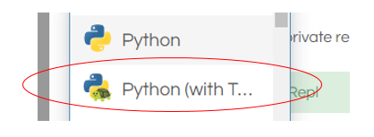

1. Begin all of your turtle programs with the following code to create a “pen”:

import turtle

myPen = turtle.Turtle()

1. Review the following chart for a list of Turtle commands.

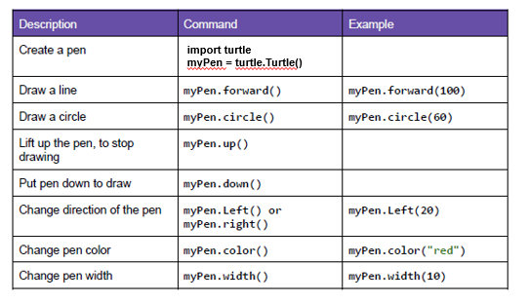

1. Use the following program to draw a red square.

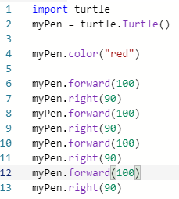

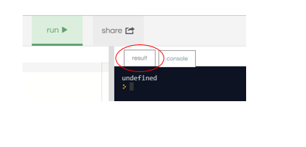

1. Switch to the “Result” window to see the square.
2. Create a program to draw any one of the shapes “b”, ”d”, or “e” shown in the figures below.   
   Provide a listing of your program code.

Question D:

import turtle

myPen = turtle.Turtle()

myPen.color("blue")

myPen.right(45)

myPen.forward(150)

myPen.right(180)

myPen.up()

myPen.forward(75)

myPen.right(90)

myPen.forward(75)

myPen.down()

myPen.right(180)

myPen.forward(150)

1. Create a program to draw any one of the shapes “c”, or “f” shown in the figures below.   
   Provide a listing of your program code.

Question C:

import turtle

myPen = turtle.Turtle()

myPen.color("blue")

myPen.circle(50)

myPen.color("red")

myPen.forward(50)

myPen.left(90)

myPen.forward(100)

myPen.left(90)

myPen.forward(100)

myPen.left(90)

myPen.forward(100)

myPen.left(90)

myPen.forward(100)

myPen.left(90)

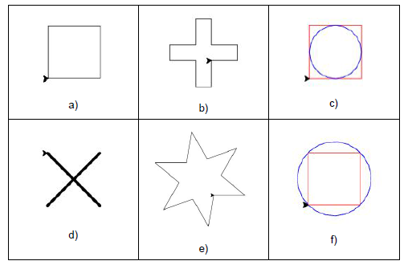

**Step 2: Christmas / Winter Theme Card**

1. Use your creativity to create a card design using Turtle.
   1. The design must have multiple figures.
   2. The design must have at least two different patterns.
   3. You may repeat patterns.
   4. Provide a listing of your program code.
   5. Provide an image of your program result.

import turtle

t = turtle.Turtle()

def draw_circle(color, radius, x, y):

t.penup()

t.fillcolor(color)

t.goto(x,y)

t.pendown()

t.begin_fill()

t.circle(radius)

t.end_fill()

draw_circle("#C8C8C8", 30, 0, -40)

draw_circle("#C8C8C8", 40, 0, -100)

draw_circle("#C8C8C8", 60, 0, -200)

draw_circle("#000000", 2, -10, -10)

draw_circle("#000000", 2, 10, -10)

draw_circle("#FF6600", 3, 0, -15)

draw_circle("#000000", 2, 0, -35)

draw_circle("#000000", 2, 0, -45)

draw_circle("#000000", 2, 0, -55)

t.penup()

t.goto(-15,-35)

t.pendown()

t.pensize(5)

t.goto(-75, -50)

t.penup()

t.goto(15,-35)

t.pendown()

t.pensize(5)

t.goto(75, -50)

t.penup()

t.goto(-35, 8)

t.color("saddle brown")

t.pensize(6)

t.pendown()

t.goto(35, 8)

t.goto(30, 8)

t.fillcolor("saddle brown")

t.begin_fill()

t.left(90)

t.forward(15)

t.left(90)

t.forward(60)

t.left(90)

t.forward(15)

t.end_fill()